

**Software platform for the Internet of Connected Objects and increased assistance to field agents.**

**PFE2020#70**

**Nom de l'encadrant :**

Jean-Yves TIGLI

**Nom du Co-encadrant :**

Gaëtan Rey

**Noms des membres du groupe :**

Khaoula Haj Mahmoud : Master 2 Ingénierie Informatique - IAM Tianyan Zhang : Master 2 Ingénierie Informatique - IAM

Sommaire

Introduction 3

I. Objective 3

II. technological tools………………………………………………………………………………………………………………………………………4

1- WComp 4

2. NODE-RED 5

3. UPNP Designer………………………………………………………………………………………………………………………………………………….6

III. explication of LCA metamodel…………………………………………………………………………………………………………………6

IV. Technical development 6

V. Travail restant 6

VI References…………………………………………………………………………………………………………………………………………………..6

# Introduction

# In recent years we have often heard the term "BYOD" (Bring Your Own Device), a trend often used by companies to allow their agents to use their personal equipment in a business context. But with the evolution of the IOT field, each human agent has a lot of connected objects (smartphone, tablet, connected glasses ...). And when we invoke the IOT domain, the dynamic nature of the services related to these objects and their availability is the first thing that comes to mind. The appearance and disappearance of these connected objects around the agent makes the development of software assistants that can communicate with each other more complex. In software terms, this requires the implementation of self-adaptive software layers because these devices use different communication protocols and interfaces. This kind of problem has led a research team In I3S laboratory to create a prototype, WComp which adapts itself to the evolution of infrastructure in terms of the evolution of services available at any given time.

WComp based on the composition of components and services witch for serve years now represents a potential solution for the construction of large software packages by breaking down features into smaller and, if possible, independent entities that then need to be assembled. And all of these are seen in the LCA (Lightweight Components Architecture) model that is running correctly under WComp, but the main the main problem, WComp is not comercialisable that ‘s why we will transform LCA model under NODE-RED flow and make a graphical interface for filed officiers.

# Objective

Our purpose in this project is to develop and construct a software system to support the continuity of user services by dynamically taking context into account. This platform should also make it possible to recognize the availability and existence of the services and to adapt our application to the development of the infrastructure of the services in order to conform to the reality of the sector.

to achieve this goal, we have to start by reapplying the functions implemented in the LCA model of WCOMP graphical editor into the NODE-RED. This is done in the following way:

After learning and comparing the metamodel of Lca model and Node-red model, we should create a web service, which can dynamically convert between lca model and node-red model, and then it will provide an api to the language with command of Wcomp, and the corresponding changes will be by calling node-red api which use WS REST for applying in node-red. The architecture is shown as below:

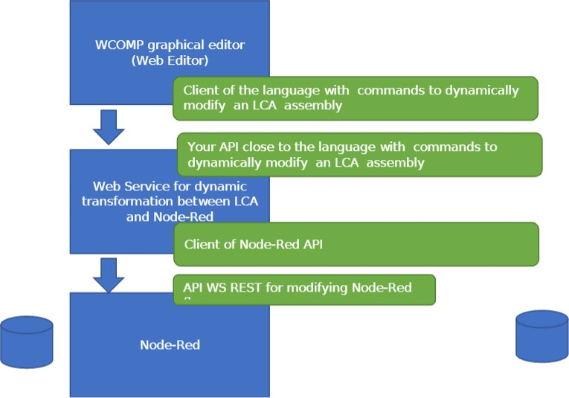

1. **technological tools**

let’s start by presenting the different tools necessary to implement our objective.

# WComp

# WComp as a container in which case the proxy components are described by Beans.

# Therefore, a Bean represents a detected devices or service. Each Bean has for inputs its methods, and for outputs its events. When the event e1 of Bean A is triggered, the method m1 of Bean B is called.

# In the case of a complex connector between two components is a connection between a typed event whose type of return value does not correspond to the type of the input parameter of the method. For this purpose, a getteur returning the right type of value is called when the event is triggered. The return value of the getteur is then used as an input argument of the method ( setteur).

# Capture d’écran (54).png

# 2. NODE-RED

# Node-RED is an open source JavaScript-based development environment based on

# Node.js, supported by IBM engineers and most suitable for developing IoT systems. More

# Specifically, It’s an easy tool to use thanks to his graphical aspect and the large quantity

# of predefined functions (MQTT broker, debug , TCP, etc) Created processes are stored

# using JSON objects.

# There are three basic elements in Node-RED: node panel, flow panel, info panel and

# debug panel. For the industry, it is important to quickly build and configure real-time

# applications. It is excellent for prototyping, thanks to its simplicity and application

# development in a short time.

# All this makes NODE-RED the pionner in the sector of Industrial Iot.

# 

# A comparative table between WComp and NODE-RED is enclosed.

|  |  |  |
| --- | --- | --- |
|  | Wcomp | Node RED |
| Simplicity | complex | Simple to use |
| implementation | .Net | Node JS  Java-script |
| Popularity | It is not comersialisable | So comersialisable |

In our case, we will use NODE-RED as a wcomp container.

**3. UPNP Designer**

The numerous services/devices available are detected using the UPnP protocol. Moreover, each time new UPnP service is discovered by the tool, it will send a command to the WComp container's the tool is connected with, to create a new proxy component corresponding to this new UPnP service.

1. **Explication of LCA model**



// explain the model in some phrases

# Technical development

## //Les étapes de transformation of the LCA Model to NODE-RED flow

With screenshots

# Travail restant

## /make a graphical interface for field officers

1. **References**